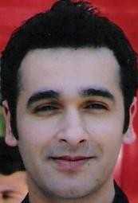
Adress: 23 Sheares street Argyle house Eircode: T12Y0EA
Cem OZALP
TEL: +353 83 409 7978
E-mail : mc_cem@hotmail.com
PERSONAL INFORMATION

Date of Birth 19.09.1982 Marital Status: Single
Military Status: Completed
Driver's license: class B

WORK EXPERIENCES
2015-2016 Istanbul Gelisim University perfusion technician department lecturer and
department chair.

2016-2017 Uşak State Hospital, cardiovascular surgery perfusionist 2017-2018 Mersin city hospital cardiovascular surgery perfusionist 2018-2022 Uşak State Hospital, cardiovascular surgery perfusionist I still works as a head perfusionist at the Usak state hospital. approximately 1200 open heart surgeries.
and approximately 100 ECMO experiences.
EDUCATION INFORMATION

2003-2007 SULEYMAN DEMIREL UNIVERSITY. FAC. OF SCIENCE AND LITERATURE. BIOLOGY

DEPARTMENT.UNDERGRADUATE EDUCATION

2011-2013 HARRAN UNIVERSITY. MEDICAL FAC. CARDIOVASCULAR SURGERY MASTER'S

EDUCATION PERFUSION TECHNIQUES
SEMİNAR ve COURSES

3-6 November 2016, Antalya 14. Turkish Cardiovasculer surgery congress.

24 November 2018 Tekirdağ, Turkish perfusionist’s society regional meeting 31 March 2018 İstanbul, Turkish perfusionist’s society regional meeting
26-29 October 2018 Antalya, 15. Turkish Cardiovasculer surgery congress

24 February 2018 Gaziantep, Turkish perfusionist’s society regional meeting
8-10 November 2019, Antalya, 5. Turkish perfusion symposium
23 February 2019 İzmir, Turkish perfusionist’s society regional meeting
9-10 November 2019 Antalya, Liva nova international perfusionist ATS, ECMO training

12-15 November 2020 Antalya, 16. Turkish Cardiovasculer surgery congress

22 February 2020 Adana, Turkish perfusionist’s society regional meeting
5-7 November 2021 Antalya 6. Perfusion Symposium

17 – 20 November 2022 Antalya 17. National Congress of the Turkish Society of Cardiovascular Surgery.

MEMBERSHİP AND CERTİFİCATİONS

TURKİSH PERFUSİONİSTS ASSOCİATİON
Member number : 630

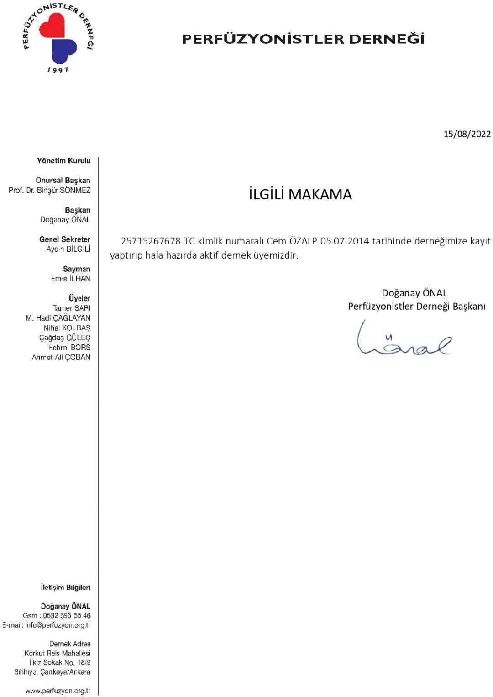

The Europen Board of Cardiovascular Perfusion

European Certificate in Cardiovascular Perfusion

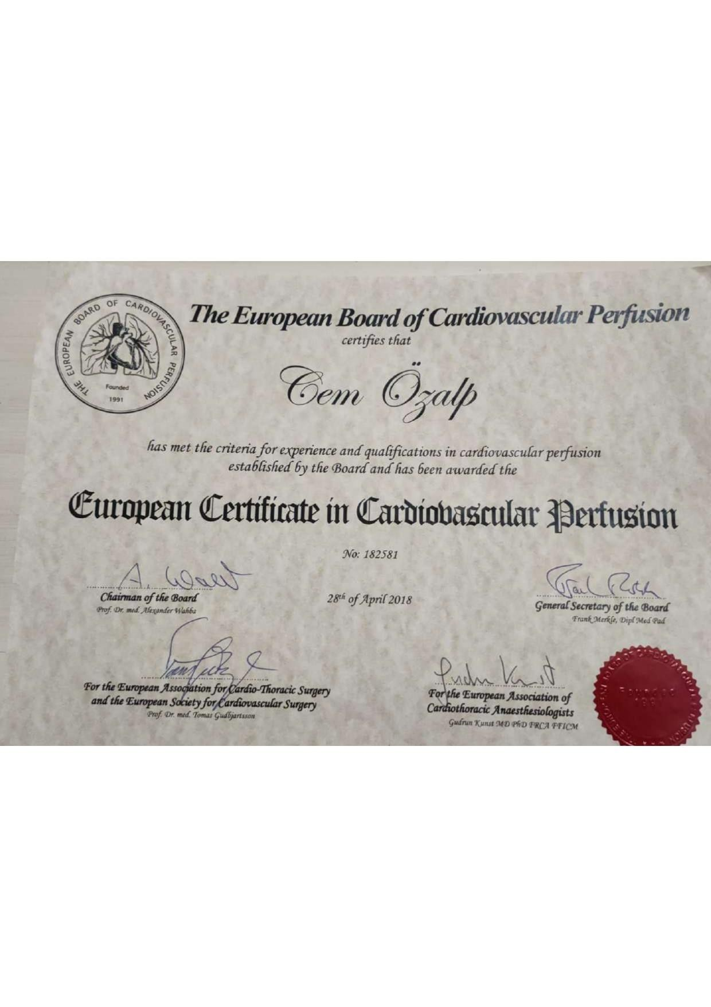member number: 182581

