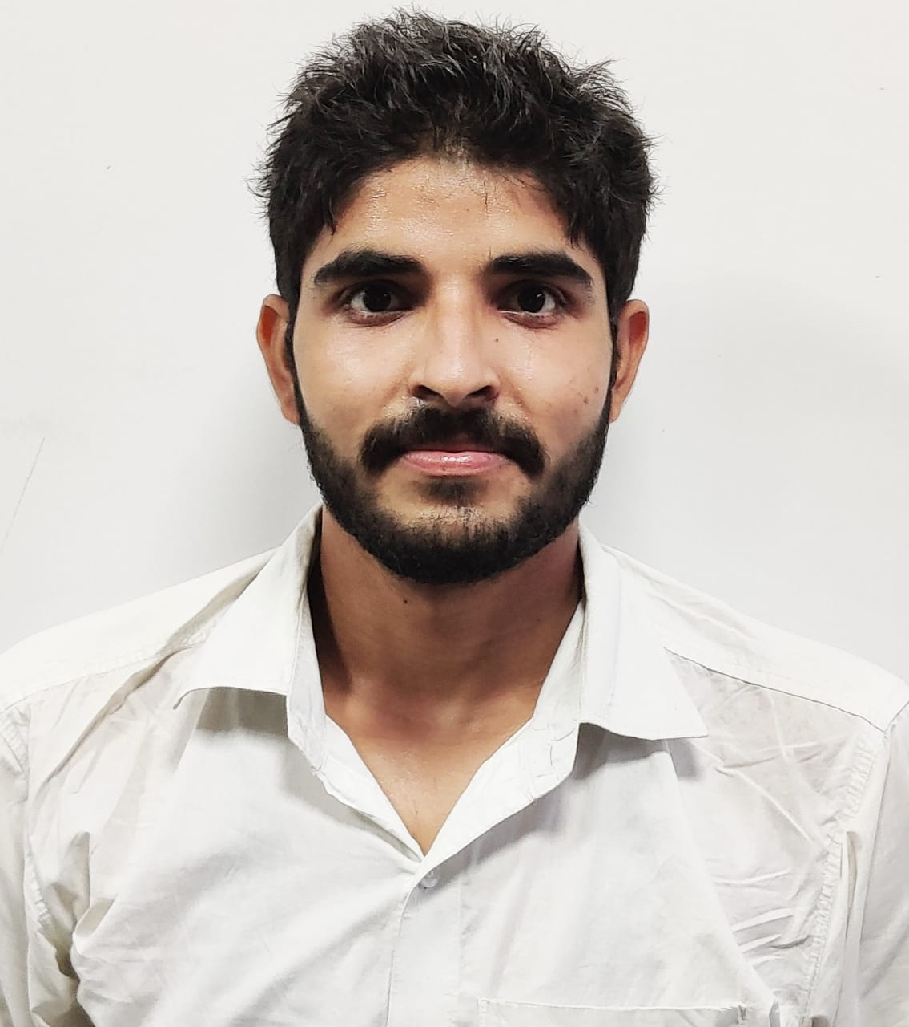

**Mr. Salman**

**D.O.B: 20/09/96**

**Behind BDPO Office , V.P.O Hathin Distt Palwal, Haryana**

**Phone**: +91- 9354457905

**Email : salmankhan20996@gmail.com**

**LinkedIn : Salman Khan**

**CURRICULUM VITAE**

**OBJECTIVES**

Seeking a reputable and explorative position as a Cardiac Perfusionist in cardiothoracic and vascular surgery department in hospitals which give new life to cardiac patients that offers a lot of challenging projects and act as an anchor in building my career.

**ACADEMIC QUALIFICATION**

**M.Sc Perfusion Technology** All India Institute of Medical Science AIIMS , New Delhi. 2018 20

**ACADEMIC SPECIFICATIONS**

|  |  |  |
| --- | --- | --- |
| COURSE | YEAR | INSTITUTION / UNIVERSITY |
| M.Sc Perfusion Technology | 2018 2020 | AIIMS , New Delhi |
| B.Sc Perfusion Technology | 2014-2017 | PGIMS ROHTAK HARYANA |
| **12th CBSE** | 2013-14 | K.C.M public School, Hodal, Palwal, Haryana |
| **10th CBSE** | 2011-12 | Meat Modal School, Hathin, Palwal Haryana |

**ACADEMIC PROJECTS**

* ***TOF REPAIR IN FIRST DECADE OF LIFE UNDER CARDIOPULMONARY BYPASS MACHINE***

**CONFERENCES**

**Participated in conference of extracorporeal technology ISECTON-2020 in AHMEDABAD Gujarat in February 2020**

**Participated in conference of PerfuTech in New Delhi in Dec 2019**

**Participated in conference of Heart transplant INSHLT in New Delhi in Oct 2019**

**Participated in conference of Extracorporeal membrane oxygenator ECMO- ASIA in Gurgaon Haryana in July 2019**

**Participated in conference of Cardiac surgery ANZECTON in Rohtak Haryana in May 2019**

**Participated in conference of Cardiac Anesthesia in New Delhi in Mar 2019**

**Participated in Terumo simulation program in Gurgaon Haryana Dec 2018**

**Participated in conference of Cardiac surgery ANZECTON in Rohtak Haryana in September 2017**

**CLINICAL TRAININGS:** *Internship program (2017 18)*

|  |  |
| --- | --- |
| **INSTITUTION / HOSPITAL** | **ACTIVITIES** |
| Pt. B. D. S PGIMS Rohtak Haryana(6month) | Operate Heart Lung Machine , operate IABP machine with total patient ICU care. |

**Currently working:**

As a Perfusionist in Sapra Hospital, Hisar Haryana.

**SKILLS**

Good Communication, Time management, problem solving , Active Listener, Good team member

**KEY STRENGTHS**

Fluent in English and Hindi, flexibility and adaptability, quick learner, teaching, positive attitude, strong work ethic, excellent at Human Relations, MS Office Word, MS Office Power-point, Enjoy working with multicultural People.

**PROFESSIONAL EXPERIENCE DETIALSMain Duties and Responsibilities:ECMO, integrated ECMO, VenoVenous ECMO, VADs and Heart Transplant experience.**

**• Conducting, monitoring and management of Cardiopulmonary Bypass (CPB) for various cardiovascular surgeries including Neonatal, pediatric and adult cases.**

**• Administration of blood products, intravenous fluids and medications through extra corporeal circuit on prescription orbyappropriateprotocol.**

**• Monitoring and management of blood gases, adequate anticoagulation of the patient, induction of hypothermia, ultrafiltration and hemodilution whenprescribed.**

**• Conducting emergency CPB for patients with cardiac arrest, conducting and management of Extra corporeal membrane oxygenation (ECMO), Intra aortic balloon counterpulsation, Left heart bypass, total circulatory arrest, Fem- Fem bypass, Retrograde & Antegrade cerebral perfusion, modified ultra filtration, different techniques for myocardial protection and Auto transfusion procedures. Routine quality control calibrations of various equipments used in cardio pulmonary bypass and other circulatory assistdevices. TYPES OF CASES ATTENDED**

**Heart Transplantation, Mitral & Aortic valve repair Ross’sprocedures, Coronary artery bypass graftingprocedures, Various procedures for aorticaneurysm, Atrial septal defectclosure, Ventricular septal defectclosure, Tetrology of FallotRepair, Total anomalous pulmonary venous connectionRepair, ALCAPARepair, Interrupted aortic archrepair, Ebstein’s AnomalyRepair, RastelliProcedure, BD Glenn shunt and Fontancompletion, Truncus arteriosusRepair, Senning’soperation, Arterial switchoperation**

**EQUIPMENTS HANDLED**

**Heart – Lung Machines: Sarns - 8000, Maquet HL20**

**ECMO Systems: Maquet RotaflowECMO**

**Heater cooler system: SarnsTCM, Maquet Heater-cooler unit hcu40, Maquet620**

**IABP Machines: Maquet-Data Scope (CS 100 &CS300)**

**Cell Saver Machines: Medtronic–Autologous**

**References:**

**1) Dr. Sachin Talwar**

**Cardiothoracic and vascular surgeon,**

**AIIMS , New Delhi**

**2) Dr. S.S Lohchab**

**Cardiothoracic and vascular surgeon,**

**PGIMS Rohtak Haryana**

**Contact no. - +91- 9416050122**

**3) Dr. V. Devagourou**

**Cardiothoracic and vascular surgeon,**

**Contact no.- +91-9899623016**

**AIIMS New Delhi**

**4) Dr. P. Rajashekar**

**Cardiothoracic and vascular surgeon,**

**AIIMS New Delhi**

**5) Dr. Jai Bhagwan**

**Cardiothoracic & vascular surgeon**

**Sapra Hospital**